SIMATS ENGINEERING
ASSESSMENT TOOL 3(LOW)-Application Based Question

COURSE NAME: R PROGRAMMING COURSE CODE: ITA04

COURSE OUTCOME COVERED

CO: Apply R programming fundamentals including data structures, vectors, matrices, arrays, and class types to perform mathematical operations and manage data effectively.
(Bloom Level -BL2- BL4)

Assessment Tool Weightage: 20%

QUESTIONS: Total Marks: 100

1. Student Performance Analysis
A college stores the marks of 10 students in Mathematics, Physics, and Chemistry. Write an R program to:
- Store the marks in a matrix.
- Calculate subject-wise averages.
- Find the highest and lowest scorer in each subject.
- Display students scoring above the overall average.
CODE:
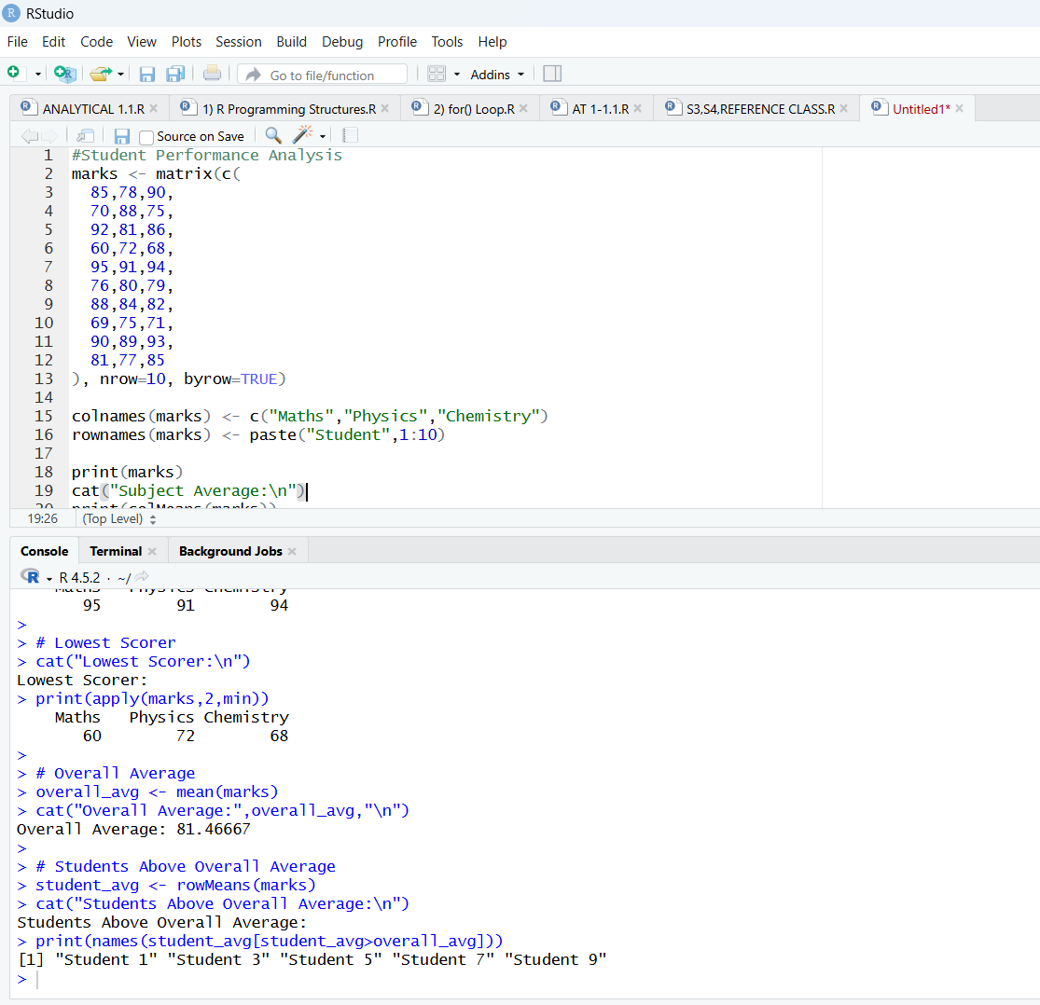

2. Employee Salary Processing
An organization maintains employee details including Employee ID, Name, Basic Pay, and Allowance.
Write an R program using appropriate data structures to:
- Calculate Gross Salary.
- Identify employees earning above ₹50,000.
- Display the employee with the highest salary.
- Generate a summary report.
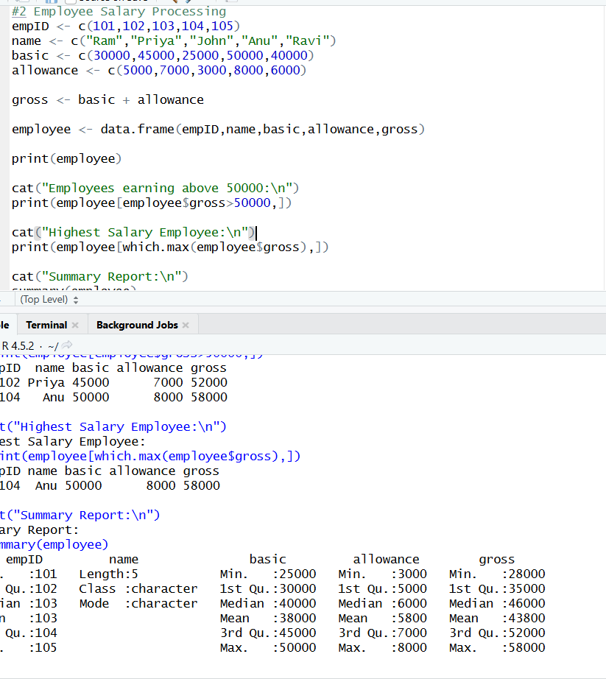

3. Weather Data Analysis Using Arrays
Daily temperature data for three cities is collected for 7 days.
Write an R program to:
- Store the data in a 3-dimensional array.
- Find the average temperature for each city.
- Identify the hottest day.
- Compare city-wise temperature variations.
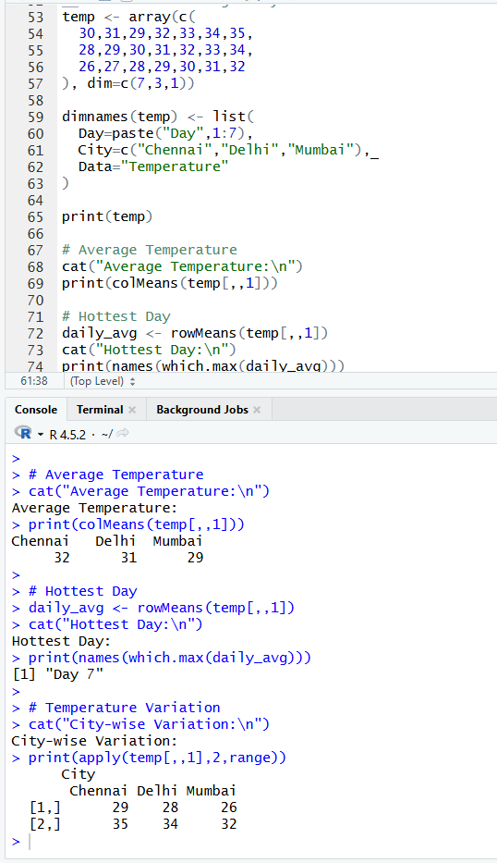

4. Product Inventory Management
A store maintains product information such as Product ID, Product Name, Quantity, and Price.
Using lists and vectors in R:
- Calculate inventory value for each product.
- Find products with stock below a threshold value.
- Generate a stock summary report.
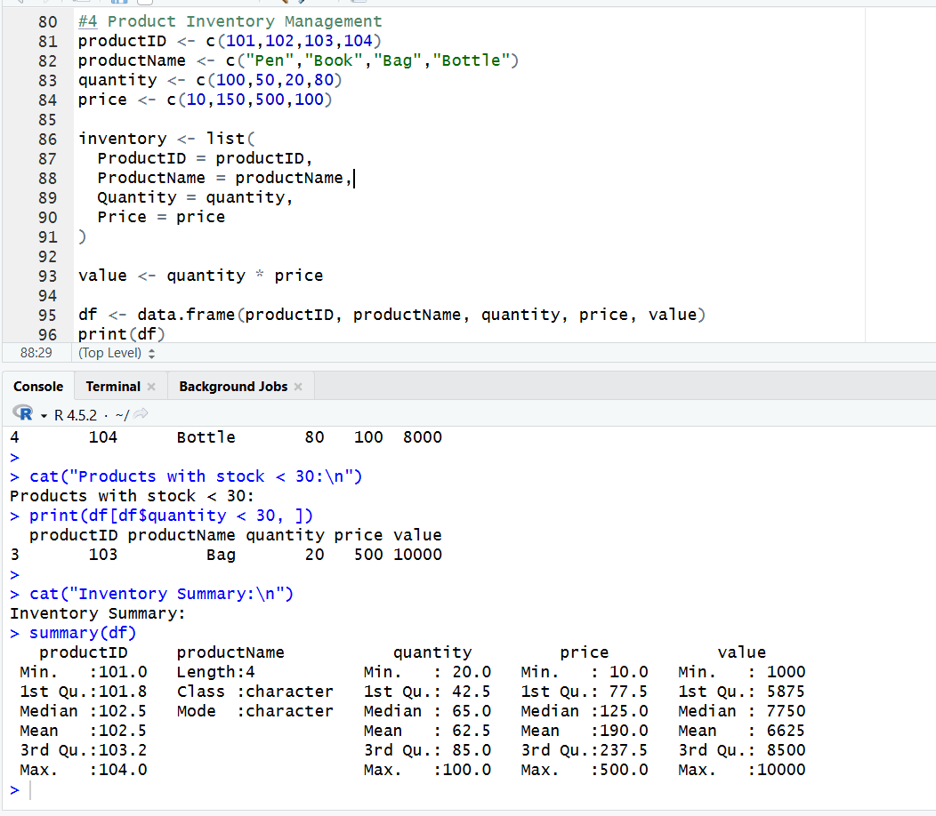

5. Bank Account Processing Using Functions
Develop an R program with user-defined functions to:
- Deposit money.
- Withdraw money.
- Check account balance.
- Display transaction history.
Use suitable variables and functions.
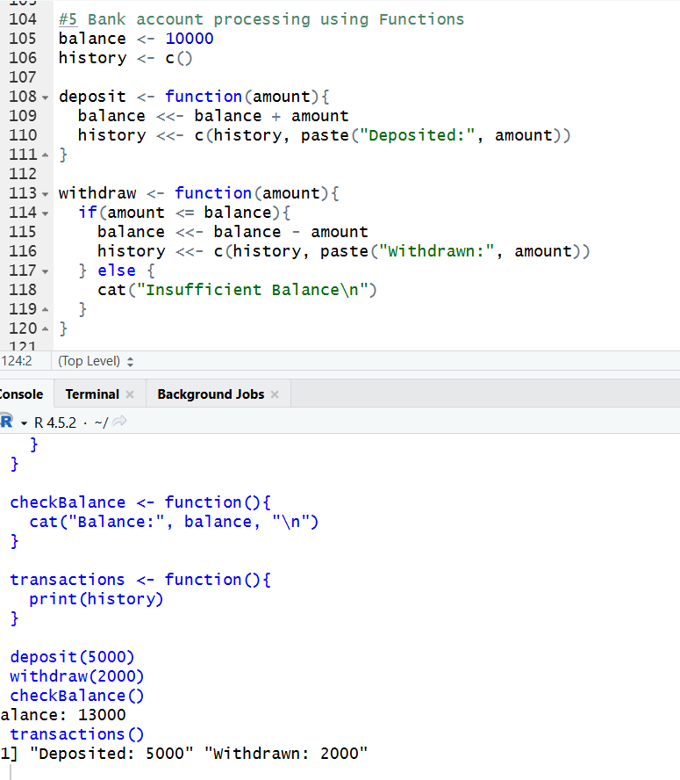

6. Hospital Patient Data Analysis
A hospital stores patient details including Age, Gender, and Treatment Cost.
Write an R program to:
- Store the information in a data frame.
- Calculate average treatment cost.
- Find patients above 60 years of age.
- Generate statistical summaries.
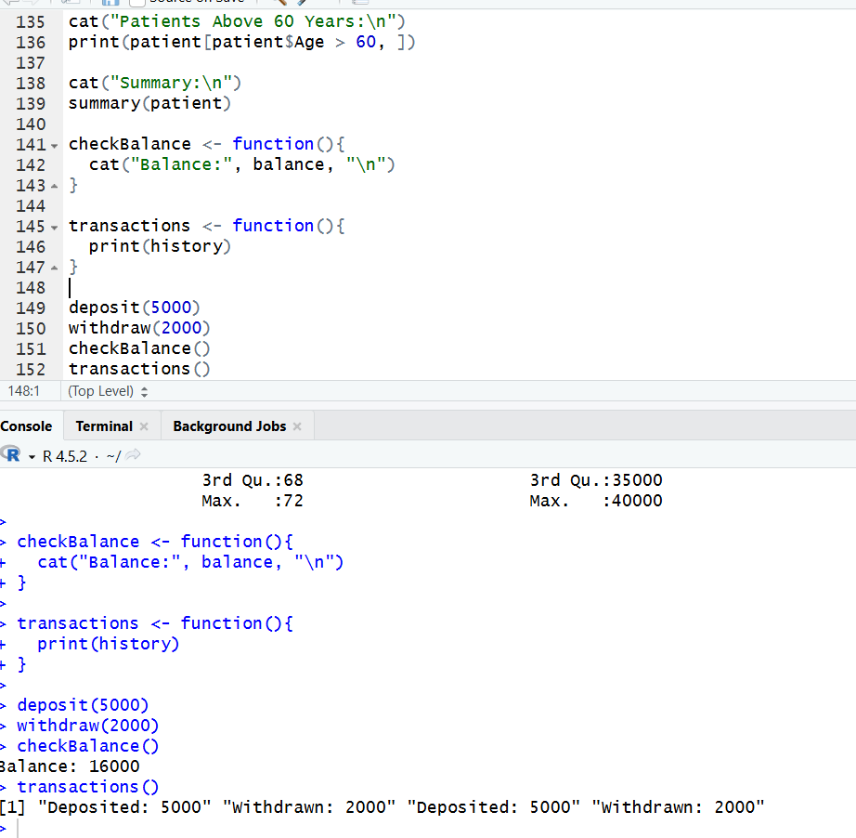

7. Logical Vector-Based Voting Eligibility System
Create a dataset containing Name and Age of citizens.
Using logical vectors:
- Determine voting eligibility (Age ≥ 18).
- Count eligible and ineligible voters.
- Display the percentage of eligible voters.
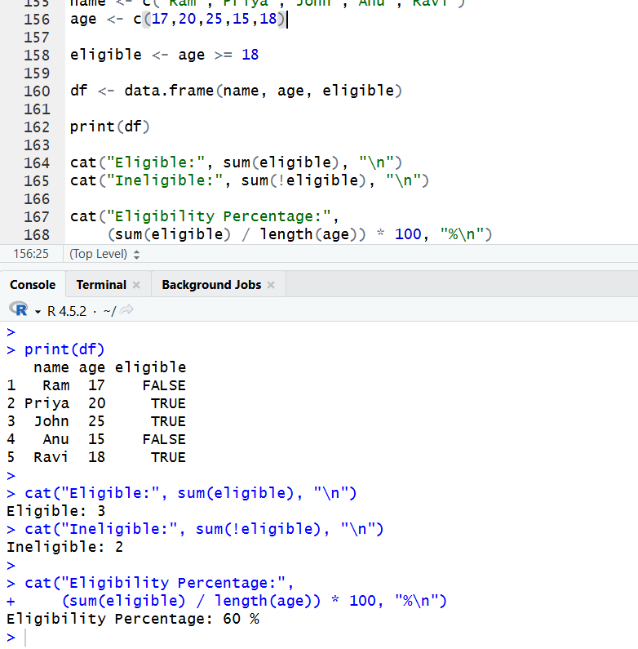

8. Matrix-Based Sales Analysis
A company records monthly sales for four products across three regions.
Write an R program to:
- Store the sales data in a matrix.
- Calculate region-wise and product-wise sales totals.
- Identify the best-performing product.
- Display the region with maximum sales.
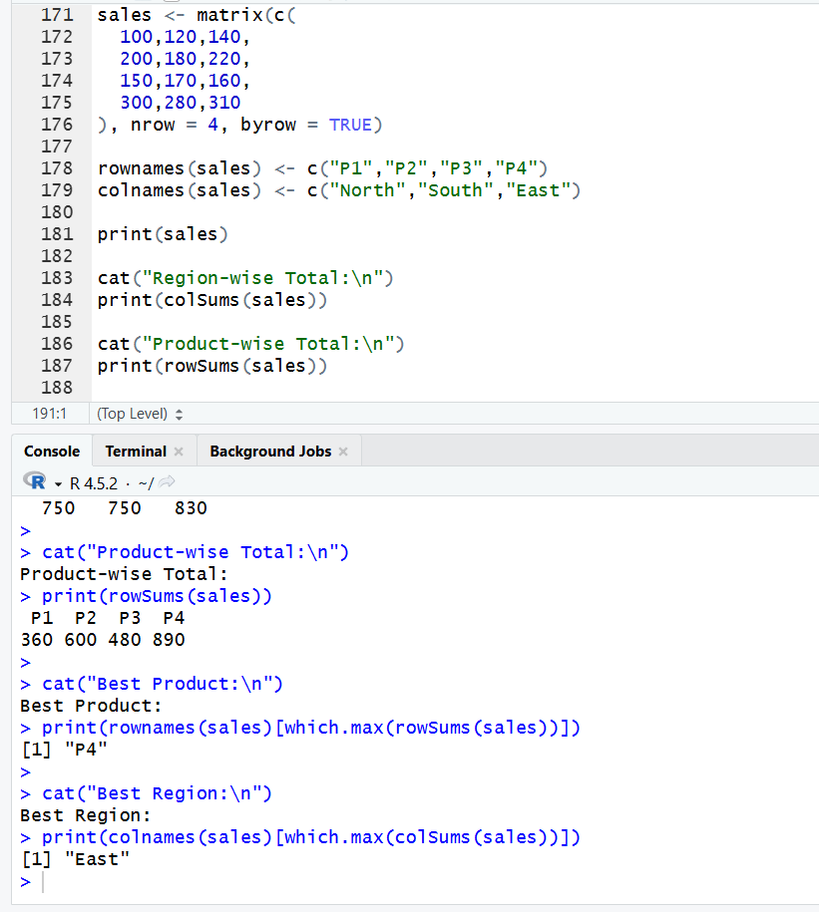

9. Library Management Using S3 Class
Design an S3 class named Book with attributes:
- Book ID
- Title
- Author
- Number of Copies
Write methods to:
- Display book details.
- Update available copies.
- Search for a specific book.

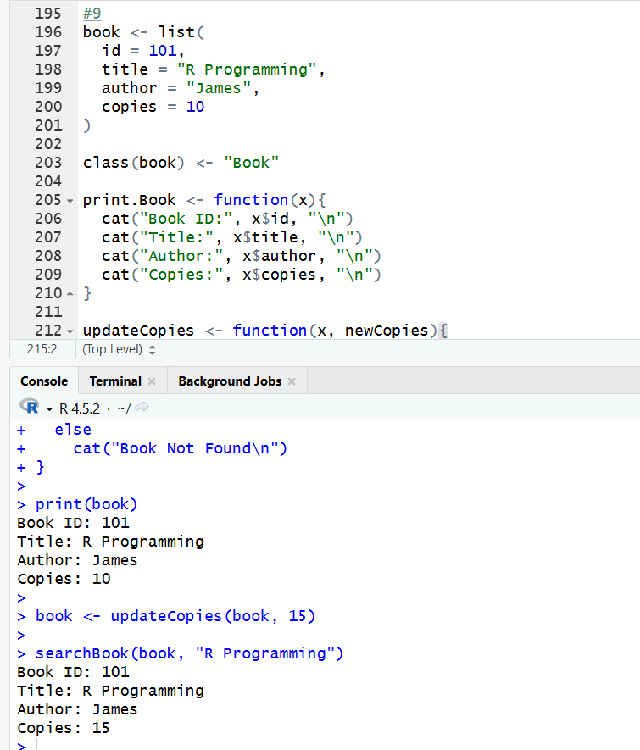

10. University Information System Using S4 Class and Reference Class
Create an S4 class named Student with slots:
- Roll Number
- Name
- CGPA
Create a Reference Class to:
- Add student records.
- Modify CGPA.
- Display student details.
- Find students with CGPA greater than 8.0.
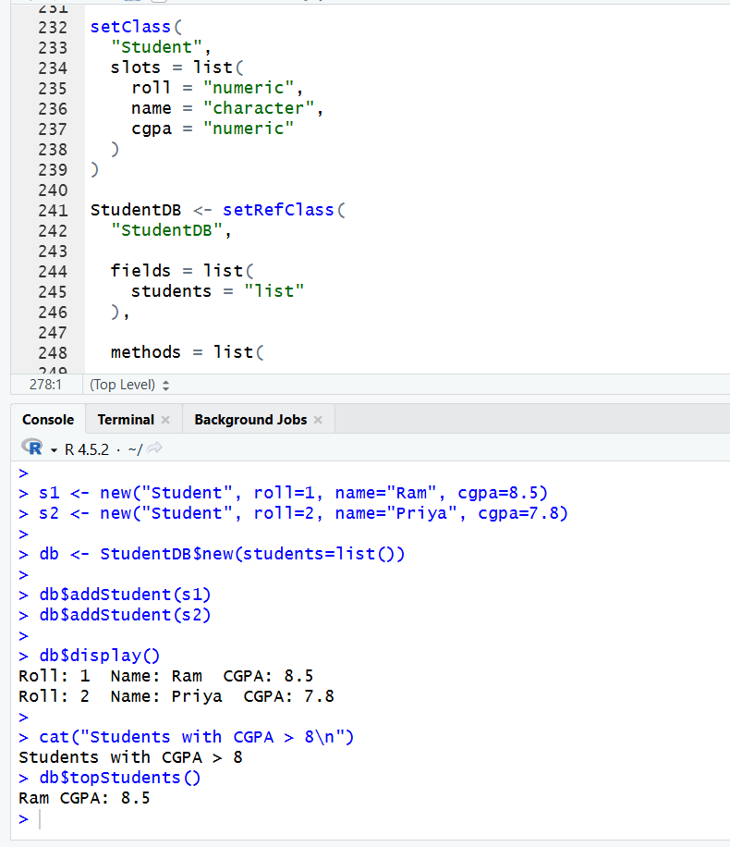

Code of Conduct:

I R.SABARISH 192324092 certify that this submission is my original work and that I have adhered to the guidelines specified for this assessment.
I understand that any violation of academic integrity rules will result in disciplinary action.

Signature of the student:

RUBRICS FOR CALCULATION:

Criteria | Weightage | Level 4 – Exemplary | Level 3 – Proficient | Level 2 – Developing | Level 1 – Beginning
Understanding of Problem Context | 20 | Clearly understands the problem and accurately identifies all requirements | Good understanding with minor gaps | Basic understanding; some requirements unclear | Poor understanding or misinterpretation of the problem
Application of Concepts | 30 | Accurately applies appropriate concepts to solve complex problems | Applies relevant concepts correctly with minor errors | Applies basic concepts with limited accuracy | Fails to apply appropriate concepts
Problem-Solving Approach | 20 | Logical, well-structured, and efficient approach | Mostly logical approach with minor gaps | Basic approach with some inconsistencies | Illogical or unclear approach
Accuracy of Solution | 20 | Completely correct solution with proper justification | Mostly correct with minor errors | Partially correct solution | Incorrect or incomplete solution
Clarity | 10 | Clear, well-organized, and properly explained solution | Understandable with minor clarity issues | Limited clarity and explanation | Poorly presented and difficult to understand

